Queensland University of Technology
IFN736 – Assignment 3
Guided Reflective Practice Portfolio
Student Name: Saarah Fariheen Sayeed
Student Number: N1214552
Group Number: 18
Group Name: Penta Intelligence
Project Name: ReadAlert
Submission Date: 20/10/2026

Table of Contents
Introduction 2
Section 1 – Project Management Processes 3
Section 2 – Industry Partner Collaboration 8
Section 3 – Ethical Business Practice Considerations 13
Conclusion 16

Introduction
I am a postgraduate student at QUT completing the final semester of my Master of Information Technology. IFN736 Industry Project Phase 2 is the capstone unit of my degree, and this reflective portfolio documents my experience working within Team 18 - Penta Intelligence - on the ReadAlert module of the Cobble SaaS platform, in collaboration with our Industry Partner (IP), Wayne Wood from the Cyber Security Centre.

My primary responsibility this semester was the Log/Scan (Book Lookup) module: an ASP.NET Core Minimal API and HTML/JavaScript frontend enabling members to search for books by title, author, or ISBN, scan a physical book by ISBN-13 barcode, and manage their personal reading records. All data access is scoped to the authenticated member’s tenant, enforced through inline JWT validation and SQL Server SESSION_CONTEXT.

At the point of this submission, the team has completed all five individual modules - Reader Profile (Amisha Patel), Author Catalogue (Sude Karadeniz), Book Catalogue (Julia Iezzi), Reading Record (Ghazal Abdolah Zadeh Javazm), and Log/Scan (myself) - and is actively merging them into a single integrated codebase. A technical documentation handover and live demonstration to Wayne are still pending.

This portfolio reflects on project management, Industry Partner collaboration, and ethical practice, drawing on artefacts including our Jira project board, five sets of SCRUM meeting minutes, the Ways of Working Charter, the Risk Register, and documented Wayne meeting transcripts.

Section 1 – Project Management Processes

Over the course of this semester, Team 18 operated within a structured Agile-SCRUM framework. We held five formal Work-in-Progress (WIP) SCRUM meetings with tutor Rebecca Jefferies (Weeks 2, 5, 7, 9, and 11), conducted regular internal team check-ins between fortnights, and maintained an active Jira board - the huddle_up project - which carried over from Phase 1 and grew to over 459 tickets by the end of semester. Each WIP meeting followed the three-stage structure documented in our Ways of Working Charter: Sprint Review, Retrospective, and Planning.

Figure 1 below shows the team’s Jira SCRUM board as at 19 October 2026, reflecting the final sprint state across all five modules.

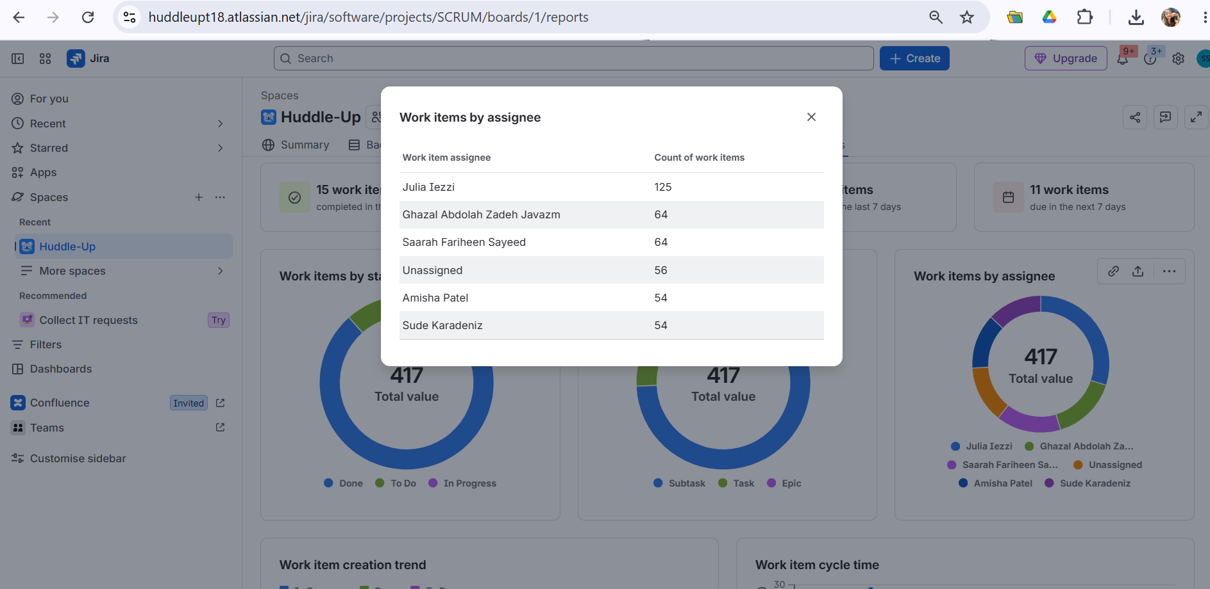
Figure 1: Team 18 Jira SCRUM Board
Q1: What were the primary successes and challenges in adhering to Agile development practices?
The most significant success was the discipline of breaking a large, open-ended deliverable into small, manageable sprint goals. When I first engaged with Wayne’s ReadAlert specification in late August, the overall scope felt overwhelming: five interconnected modules, stored procedures I had never worked with, and an ASP.NET Core Minimal API architecture that differed substantially from the Node.js plugin I had built in Phase 1. What made it manageable was committing each sprint to a focused, achievable slice of work rather than attempting to build everything at once.

By SCRUM 4 (18 September), I was able to report concretely: local development environment configured, Cobbled NoRLS database created, all RAL tables and stored procedures deployed, seed book data loaded, two POST API endpoints for book search and scan implemented and tested via Swagger UI - with no active blockers. That level of specificity in a status update is only possible when work has been broken into sprint-sized pieces with clear acceptance criteria.

The fortnightly cadence with Rebecca also created genuine accountability. Knowing I had to demonstrate two weeks’ worth of progress as a structured presentation - not just describe it verbally - meant I planned my work backwards from the meeting date rather than forward from a vague deadline.

The primary challenge was the extended scope uncertainty in the first five weeks of semester. At SCRUM 1 (31 July), the team could not pull a single development task into the sprint because Wayne had not yet confirmed the project direction. As shown in Table 1, both of the team’s highest-priority risks at that point related directly to this uncertainty.

Table 1: Team 18 Risk Register - Selected Entries (documented 3 August 2026)

Risk ID | Description | Likelihood | Impact | Response
01 | Delay in project commencement | High | Medium | Complete prerequisite activities while awaiting confirmation of new scope
02 | Uncertainty in project timeline may delay deliverables | Medium | High | Confirm project timeline with client; establish sprint goals and milestones
03 | Project requirements may change during development | Medium | Medium | Update product backlog when changes occur; communicate with team
04 | Transitioning to new project scope may require additional time | Medium | Medium | Allocate additional time for familiarisation of new scope
05 | Team may be assigned to collaborate with another team on the project | Medium | Medium | Clarify roles and responsibilities before commencing new work
06 | Delayed access to required tools or environments | Medium | Medium | Request access as soon as possible; work in backup environments if needed
07 | Additional time may be required to learn new tools or environments | Medium | Medium | Allocate additional time to explore and learn new tools/environments

Julia, as Project Manager, made the deliberate decision to use the uncertainty period productively - completing background tasks (risk register, team agreement, user stories, glossary, Course 2 exercises) rather than allowing the team to stall. This meant that when Wayne confirmed the ReadAlert scope on 21 August, the team moved immediately into development sprints without losing further time to administrative catch-up.
Q2 - How did Agile practices influence velocity, risk management, and value delivery?
The two-week sprint cycle had a direct effect on velocity. In Sprints 1 and 2 (Weeks 2 and 5), velocity was intentionally low: the backlog contained only background tasks because development could not start without a confirmed scope. Once Wayne confirmed ReadAlert on 21 August, velocity accelerated markedly - by SCRUM 4 (Week 9), every team member had individual module implementations tested and pushed to GitHub.

Figure 2 below shows the cumulative flow chart from the team’s Jira dashboard, illustrating this velocity pattern across the semester.

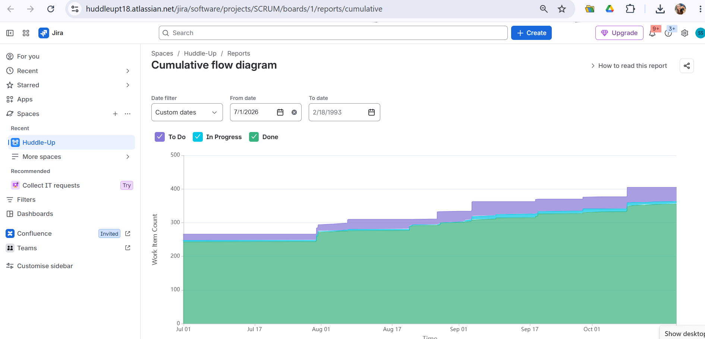
Figure 2: Team 18 Jira Cumulative Flow Chart

For risk management, the SCRUM retrospective was the mechanism that surfaced blockers before they became crises. At SCRUM 4, Ghazal disclosed she was still awaiting Wayne’s feedback on her completed Reading Record module - a dependency that could have stalled integration planning. The retrospective made this visible, and a specific follow-up action was assigned. Similarly, Amisha’s laptop freezing during dependency installation was flagged at SCRUM 4 and discussed as a team, rather than discovered only at merge time.

For value delivery, the sprint review process provided a natural decision checkpoint when Wayne introduced a new React-based working module reference after the team had already built in HTML/JavaScript. Rather than either ignoring the new reference or discarding completed work, the team used the next sprint review to assess the impact, asked Wayne directly in the 9 October meeting, and received explicit confirmation that the HTML/JavaScript implementation was acceptable for this prototype stage. The Agile process allowed the team to absorb a late-breaking change without losing momentum.
Q3: What aspect of Agile most improved efficiency and workflow?
For me personally, the most valuable aspect was the SCRUM role rotation. In Week 11, I served as Scrum Master for the first time. The experience was instructive in ways I had not anticipated. As a contributor in previous meetings, my preparation consisted of knowing my own status. As Scrum Master, I had to arrive already knowing every team member’s progress, prepare the agenda, manage time across three stages, and ensure every open action from the previous sprint was either closed or carried forward with a new owner. It required substantially more pre-meeting preparation than I had estimated.

This shifted my perspective on what it means to be a good contributor in a SCRUM team. A Scrum Master can only facilitate efficiently if team members update Jira and prepare their burndown information before the meeting, not during it. In Week 11 I was fortunate that all five team members had pushed their module code and could report clearly. Had any member been unprepared, the tutor’s ability to assess our meeting evidence would have been directly compromised.

Table 2 documents the SCRUM role rotation across all five WIP meetings this semester.

Table 2: Team 18 SCRUM Role Rotation - Semester 2 2026

Meeting | Date | Scrum Master | Scribe | Saarah Present?
SCRUM 1 (Week 2) | 31 July 2026 | Julia Iezzi | Ghazal Abdolah Zadeh Javazm | Absent
SCRUM 2 (Week 5) | 21 August 2026 | Sude Karadeniz | Amisha Patel | Present
SCRUM 3 (Week 7) | 4 September 2026 | Ghazal Abdolah Zadeh Javazm | (recorded in minutes) | Present
SCRUM 4 (Week 9) | 18 September 2026 | Amisha Patel | Julia Iezzi | Present
SCRUM 5 (Week 11) | 9 October 2026 | Saarah Fariheen Sayeed | Sude Karadeniz | Present (Scrum Master)

Beyond the SCRUM role, Julia’s sustained performance as Project Manager was the single greatest contributor to team-level sprint efficiency. She maintained the Jira backlog throughout semester, kept the meeting register current, and translated Wayne’s open-ended guidance into concrete, prioritised backlog items - a non-trivial task given that Wayne consistently communicated vision rather than specification. This meant the team always had a populated backlog to draw from at sprint planning, rather than having to generate tasks from scratch under time pressure.

Figure 3 below shows a further view of the Jira board, capturing the overall sprint ticket distribution across team members.
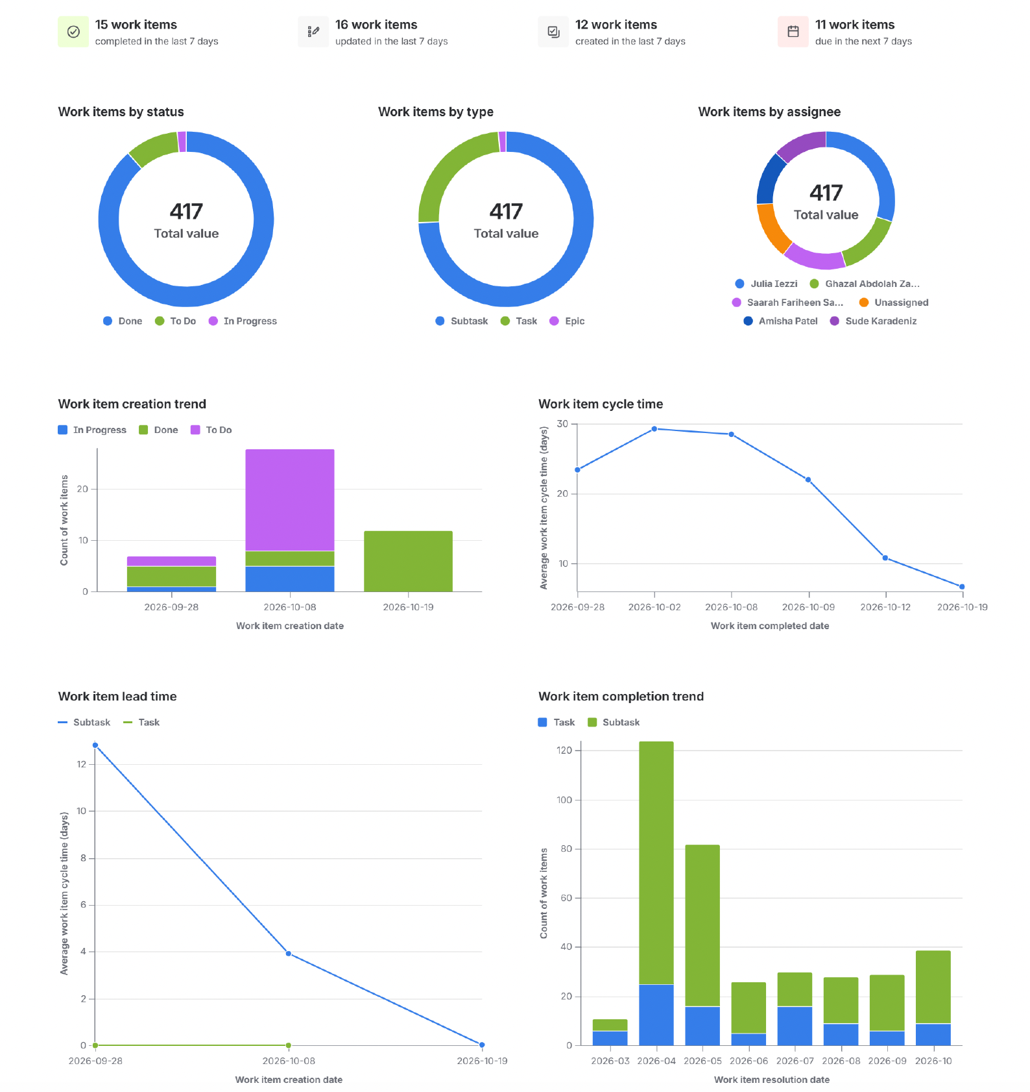
Figure 3: Team 18 Jira Board - Sprint Ticket Overview.

Section 2 – Industry Partner Collaboration

Working with an Industry Partner in a postgraduate capstone setting is qualitatively different from working to a fixed assignment brief. Wayne Wood is simultaneously the platform architect, the client, and the primary technical authority for the project. This semester, following Tatiana’s departure as Tech Lead at the start of Phase 2, Team 18 became the direct primary link to Wayne - a change that altered the communication dynamic considerably compared to Phase 1.
Q1: How did you manage communication channels, expectation setting, feedback loops, and scope changes?

The team adopted a deliberate communication structure early in the semester. Julia and Sude took primary responsibility for attending Wayne’s weekly Friday Zoom meetings (1:30pm), with all other team members welcomed but not required. This was a conscious decision: Wayne often had multiple teams across the same session and limiting attendance reduced meeting noise and made the best use of his time. After each Wayne meeting, Julia debriefed the full team through our WhatsApp group and standing internal check-ins, converting outcomes into sprint actions in Jira.

Table 3 documents the full schedule of Wayne meetings this semester, including who attended and the key outcome of each session.

Table 3: Wayne Wood Meeting Schedule - Semester 2 2026

Date | Attendees from T18 | Key Outcome
22 July 2026 | Ghazal, Julia (separate meetings) | Team restructure discussed following Tatiana’s departure
21 August 2026 | Julia, Sude | Scope confirmed: Red Alert module development path chosen; 5 modules assigned
22 August 2026 | Julia, Sude | Live Cobble platform walkthrough; Red Alert UI and architecture demonstrated
28 August 2026 | Julia, Sude | Microservice architecture confirmed; stored procedures, JSON payload pattern, no direct table access
7 September 2026 | Julia, Sude | Julia and Sude demonstrated working prototypes; Wayne provided detailed architecture feedback
9 October 2026 | Julia, Sude, others | Artefact agreement reviewed; HTML/JS frontend confirmed acceptable; merge and documentation next steps agreed

This relay structure worked well in most cases. However, it did introduce an interpretation layer between Wayne’s words and the full team’s understanding. For example, after the 28 August session, there was an internal team discussion on 29 August about whether Wayne’s architectural guidance (all SQL via stored procedures, JSON payloads, no direct table access) was a strict platform requirement or a general recommendation. This ambiguity could have been resolved with a single direct question at the Wayne meeting, but instead consumed time in a separate internal session.

Wayne was consistently available on Discord for asynchronous questions between Friday meetings, and several individual blockers were resolved this way without waiting for the next formal session. All Wayne meetings were recorded as written transcripts and filed - these became important reference documents, particularly the 22 August platform walkthrough and the 28 August architecture session.

Scope changed meaningfully twice this semester. First, on 21 August, Wayne pivoted the team from the original HuddleUp/frontend design path toward the module development path. Then on 28 August, he confirmed the full module scope and provided the stored procedures and working module reference via GitHub. Each pivot required the Jira backlog to be reviewed: outdated Project Development epic items from the original HuddleUp codebase were removed, and new sprint goals were established from scratch. The Agile framework made these changes manageable - the backlog was a living document, not a fixed contract.

Q2: What collaboration strategies proved most or least effective?

The most effective strategy was the consistent documentation of every meeting as a written transcript. Having verbatim records meant that when questions arose weeks later - such as whether the HTML/JavaScript frontend was still acceptable once Wayne released a new React-based working module reference - the team could refer directly to what had been said rather than relying on recollection. The 9 October transcript confirmed it explicitly: “I gave you the wrong EDP. No problem. You’ve got a working product.” That record provided the team with the confidence to proceed without costly rework.

Regular internal check-ins between formal SCRUM meetings were also highly effective. The Book Catalogue and Author Catalogue modules shared a technical dependency - Julia and Sude’s book and author IDs needed to correspond for the integration to work. Without the informal weekly touchpoints, this dependency would likely not have been identified until the full merge, at which point it would have been significantly harder to resolve.

The least effective aspect was the feedback loop for direct module review by Wayne. Ghazal completed her Reading Record module and pushed it to GitHub, then emailed Wayne requesting feedback - and received no direct response for several weeks. This left her unable to move confidently into front-end polish. The SCRUM 4 retrospective surfaced this as a blocker, but resolving it required her to follow up again through Discord before the 9 October meeting. This highlighted a structural limitation: when an IP is managing multiple teams simultaneously, asynchronous feedback requests can become lost. In future projects, I would recommend framing all feedback requests with a specific response-by date, so the sprint plan can account for the waiting period explicitly.

For my own module, I avoided this problem by anchoring my design closely to Wayne’s working module reference (Cobbled-EDP-3.0.0) from the outset. Because I used his established pattern as the implementation target, my work was structurally aligned to his expectations without requiring a separate approval cycle.

Figure 5 below shows the ReadAlert Log/Scan module running in the browser, with the Search/Scan tab active.

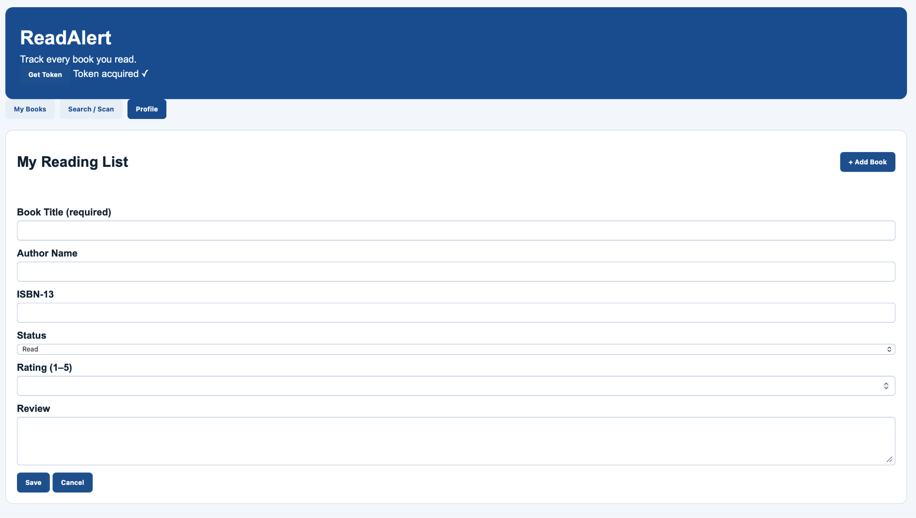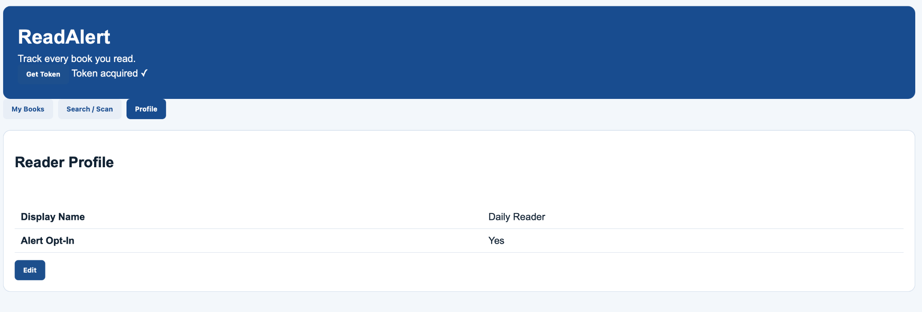
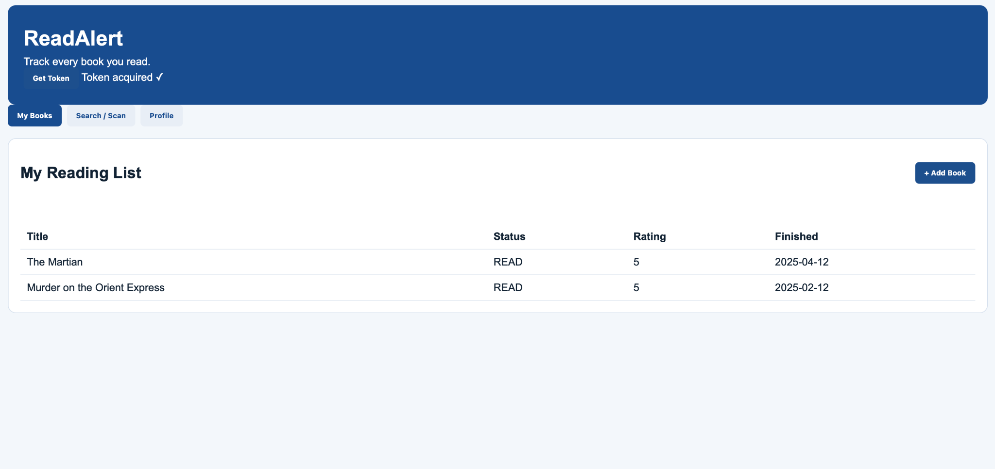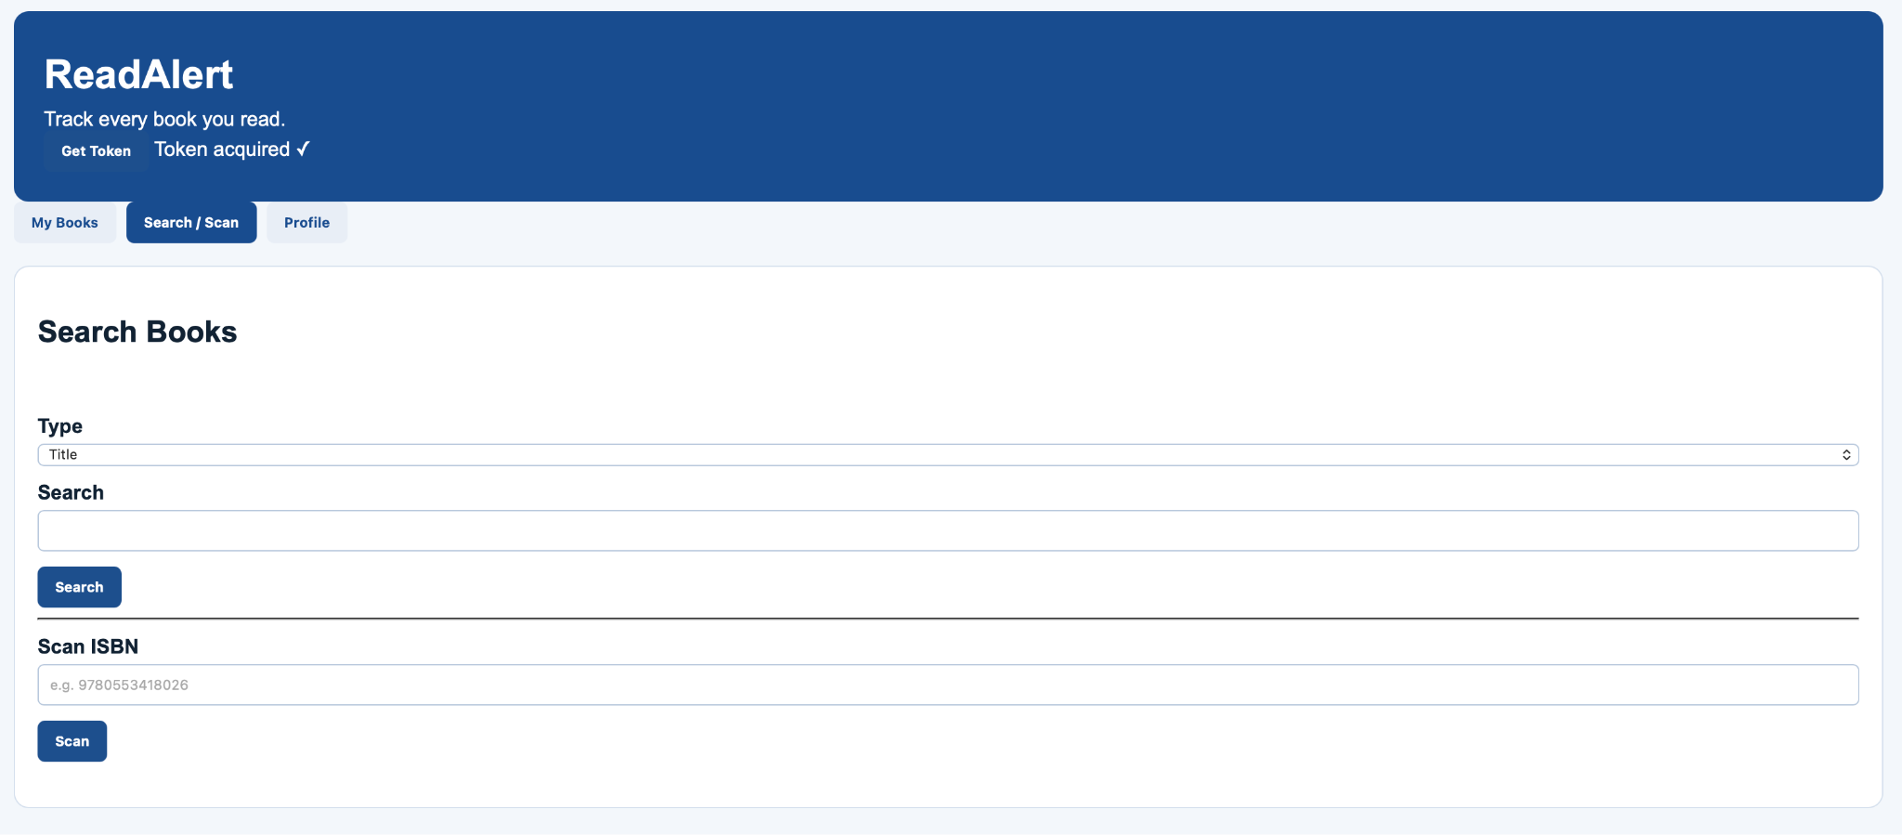

Figure 5: ReadAlert Log/Scan Module - Search/Scan interface running locally.”]

Figure 6 below shows the Swagger UI for the ReadAlert API, listing the Log/Scan endpoints.
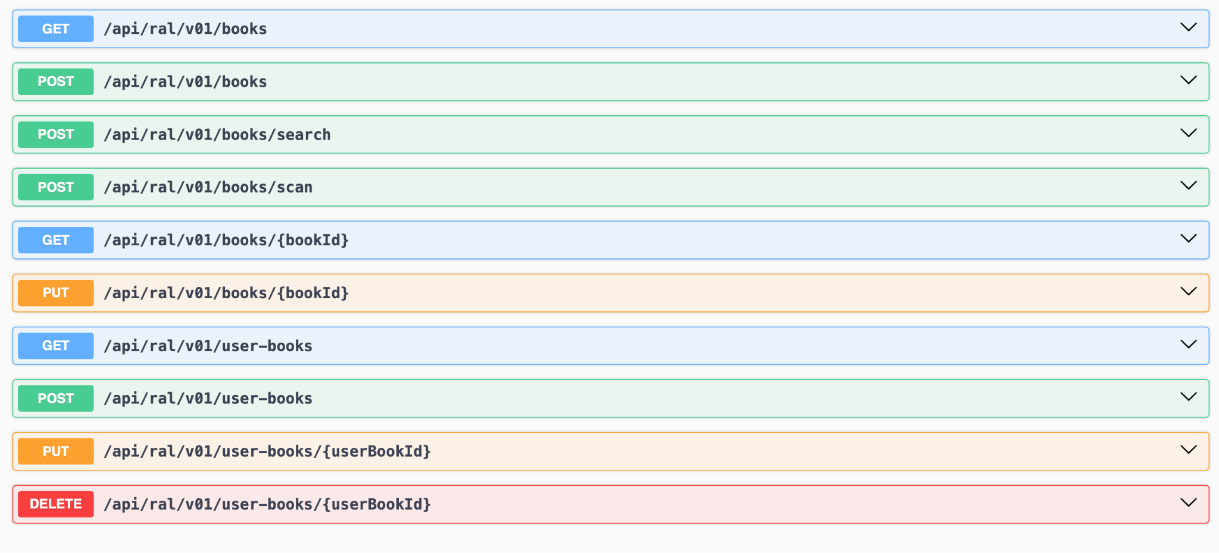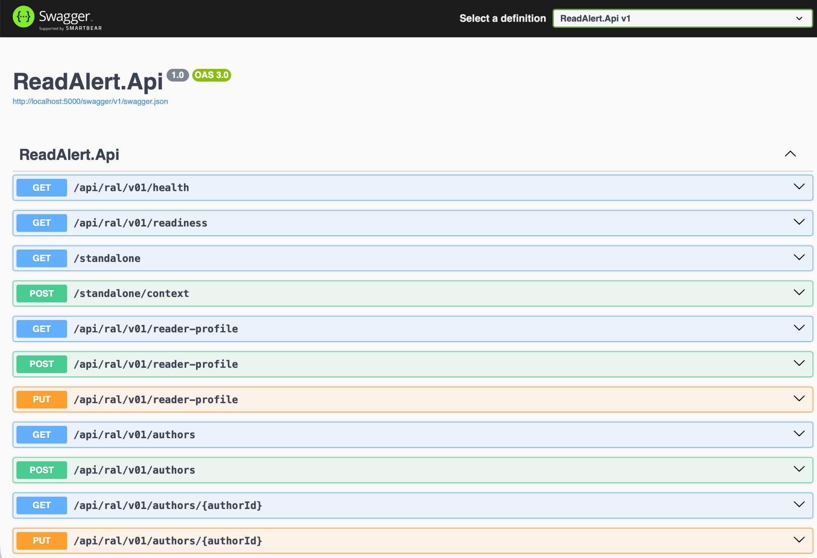
Figure 6: ReadAlert API - Swagger UI showing Log/Scan endpoints.
Q3: Was there anything IP-related that impeded progress, and how did you work around it?

The single most significant impediment this semester was the five-week gap between project start and scope confirmation. Wayne was still actively building the platform and had not finalised what he wanted from a Master’s team. This is documented in Risk Register Risk 01 (High likelihood, Medium impact) and was the defining constraint of the first third of semester.

The team’s response was deliberate: rather than beginning development against an unconfirmed scope and risking wholesale rework, Julia directed the team toward productive background artefacts during the waiting period - the risk register, Ways of Working Charter update, glossary, user stories, and Course 2 exercises. This proved to be the right call. When Wayne provided the stored procedures and architecture documentation on 28 August, the team was positioned to start development immediately without any administrative debt.

A secondary impediment was the loss of access to the team’s Application Plane GitHub repository. This is documented as Risk 06 in the Risk Register (Delayed access to required tools). Wayne had restructured the project and the original repository was no longer relevant to the new direction. The team chose not to expend effort seeking reinstatement until Wayne confirmed the situation, which was again the pragmatic call given the uncertainty at that stage.

A third impediment - one I encountered personally - was technical unfamiliarity with the Cobble platform’s authentication pattern. Wayne’s framework requires JWT validation to be performed inline in each module, without using ASP.NET’s standard authentication middleware. The expected pattern uses 'JsonWebTokenHandler.ValidateTokenAsync()' directly, extracts claims from the result, and sets 'SESSION_CONTEXT' manually before every stored procedure call. This is not a pattern covered in typical ASP.NET Core tutorials, and getting it to work correctly took considerable study of Wayne’s working module reference before I could proceed confidently.

A related challenge was configuring the signing key correctly. The 'RalSecurity:SigningKeyBase64' value in 'appsettings.json' must be a valid Base64-encoded string of sufficient length for HMAC-SHA256. An incorrectly formatted key causes the 'ValidateTokenAsync' call to throw at runtime rather than return a graceful failure, which produced unhelpful error messages early in development. Working through these issues methodically, validating each component in Swagger before proceeding to the next, was how I resolved them - consistent with the approach Wayne described in the 7 September meeting: “Get the communication working first. Once you’ve got that working, everything else is going to be the same.”

Figure 7 shows a successful Swagger test of the POST /api/ral/v01/books/search endpoint, confirming the API is authenticated, connected to the database, and returning results correctly.
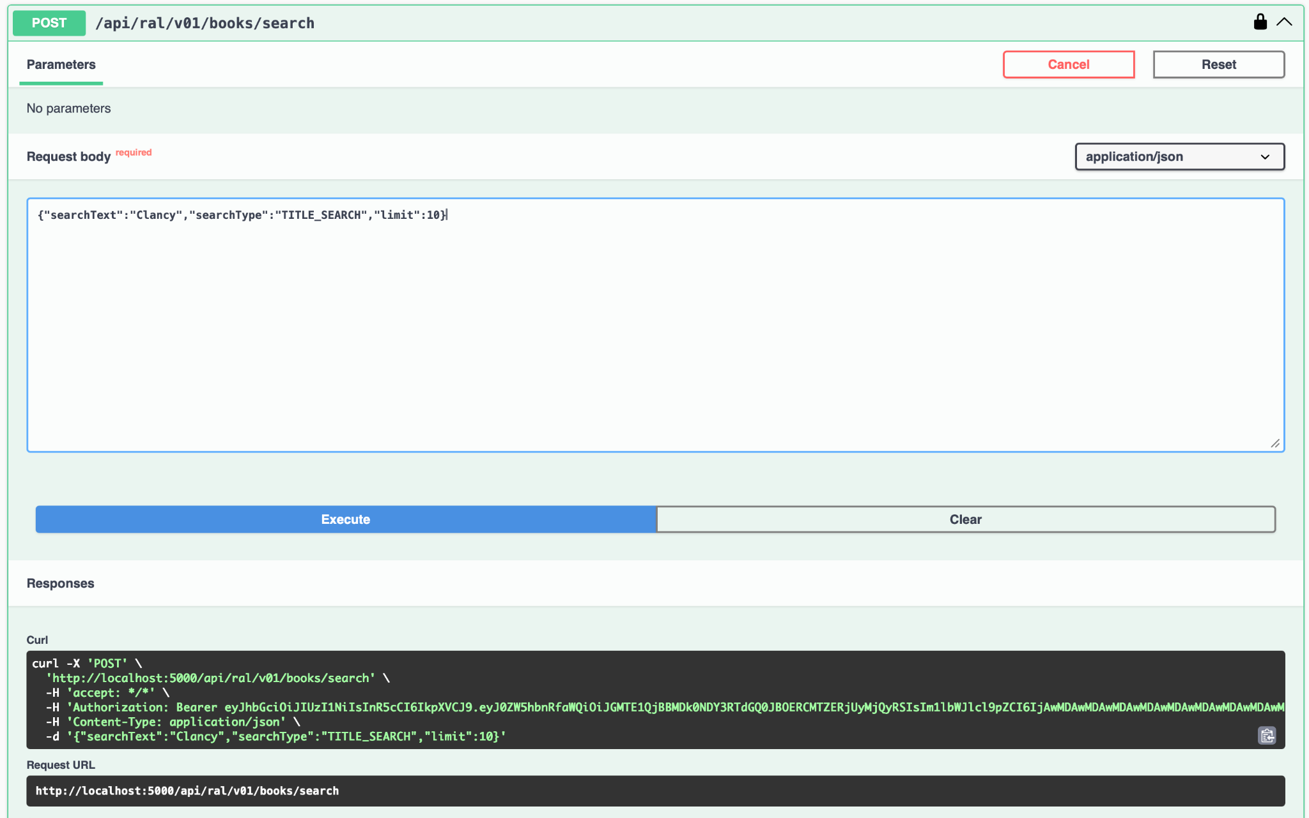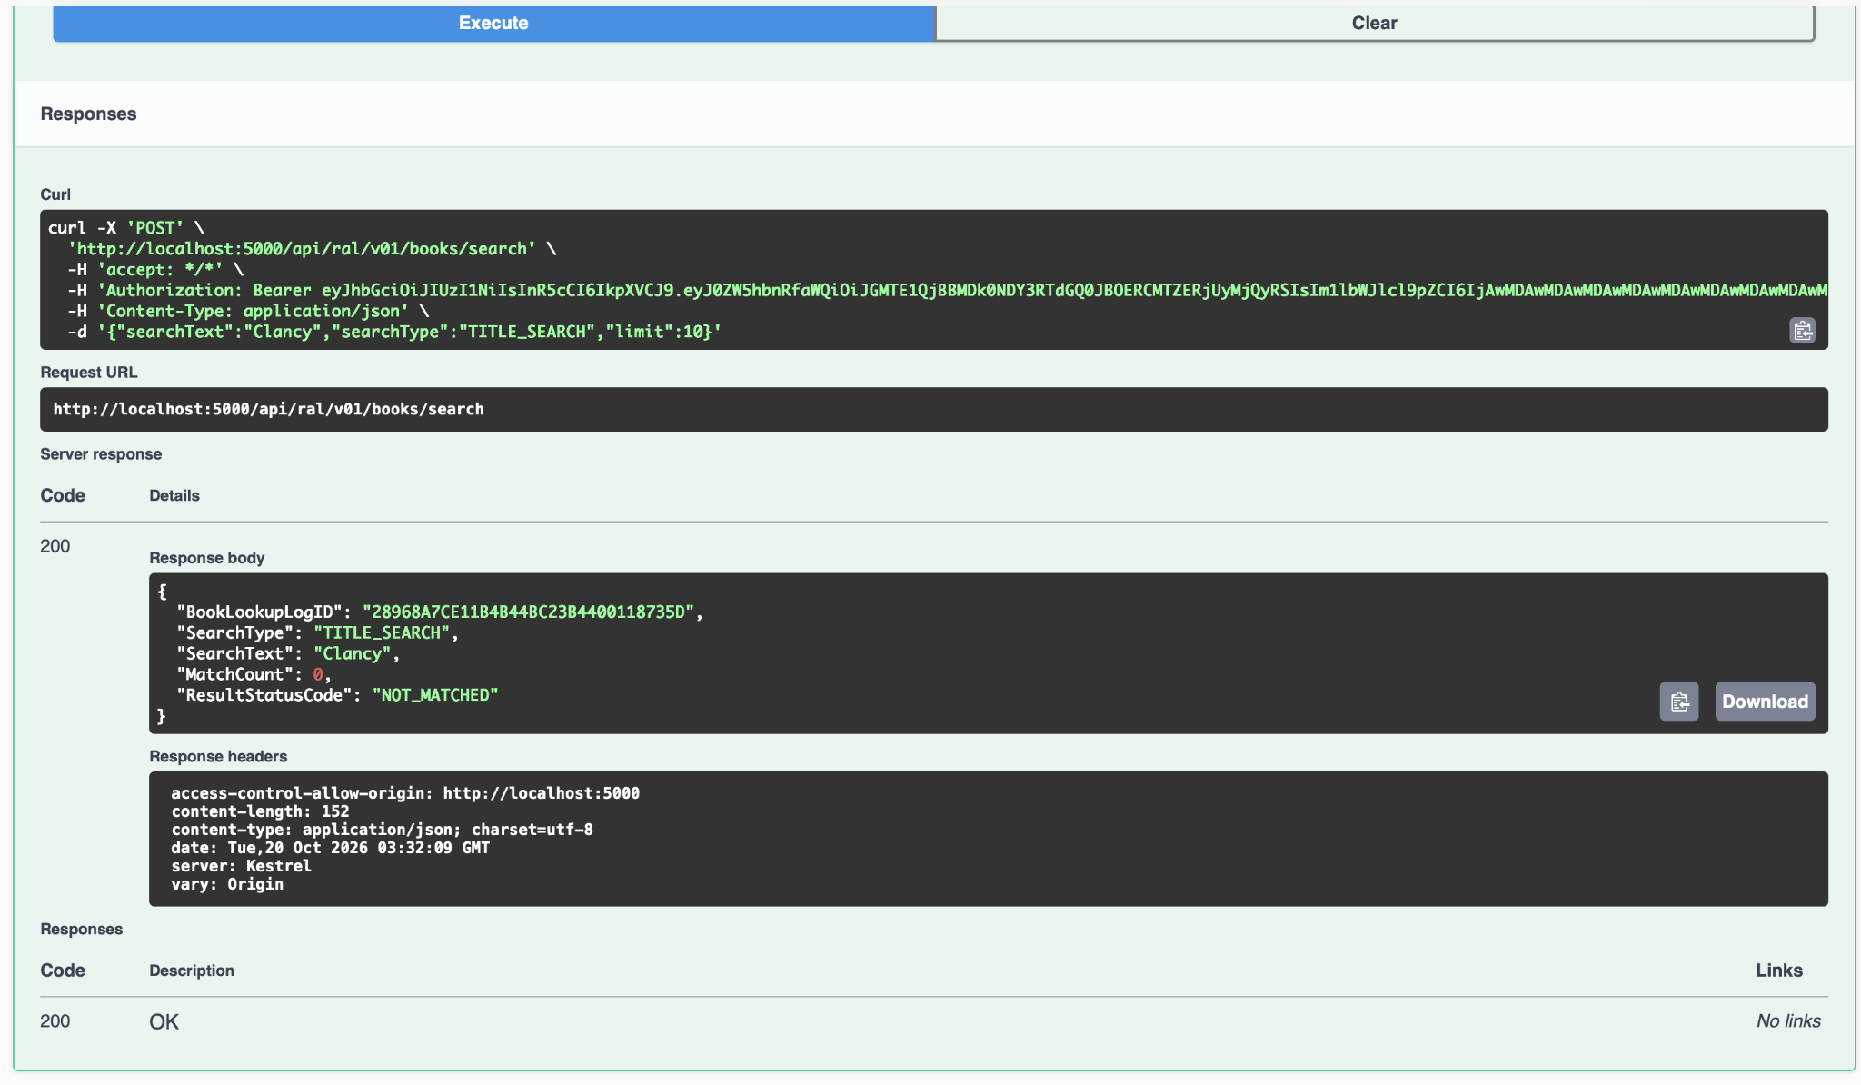

Figure 7: Swagger - Successful book search response (200 OK) from Log/Scan API

Section 3 – Ethical Business Practice Considerations

The ReadAlert project raised several genuine ethical considerations - some embedded in the technical architecture of my module, others relating to the team’s conduct, working relationship with the IP, and use of external tools.
Q1: What professional ethical frameworks or organisational policies guided your decision-making, and what broader lessons will you carry into future industry roles?

The most immediate and technically concrete ethical concern in my work was multi-tenancy data isolation. The Cobble platform is explicitly designed so that data belonging to one tenant is completely invisible to every other tenant. In my Log/Scan module, this was enforced at two distinct levels.

First, JWT validation is performed inline using 'JsonWebTokenHandler', and the 'TenantID' and 'MemberID' claims are extracted exclusively from the validated token - never from the request body, query string, or any other caller-supplied parameter. Second, before every stored procedure call, those values are written to SQL Server’s 'SESSION_CONTEXT' so the database itself enforces the isolation boundary, independently of the application layer.

The code snippet below illustrates this pattern:

foreach (var (key, value) in new[] { ("TenantID", scope.TenantId), ("MemberID", scope.MemberId) })
{
await using var ctx = new SqlCommand("EXEC sys.sp_set_session_context @key, @value", db);
ctx.Parameters.AddWithValue("@key", key);
ctx.Parameters.AddWithValue("@value", value);
await ctx.ExecuteNonQueryAsync();
}



This design directly reflects the ACS Code of Ethics (ACS, 2014), specifically:
- Primacy of the Public Interest - the obligation to prioritise the safety and privacy of those affected by a system over technical convenience.
- Honesty - not introducing implementations that, while simpler, would undermine the trust members place in the platform.

Had 'TenantID' been accepted from the request body - which would have required fewer lines of code - any authenticated user could have impersonated any tenant, exposing every reader’s data. This was not a hypothetical risk: the platform is designed to be a multi-tenant SaaS product potentially serving many independent organisations. The ethical obligation to prevent cross-tenant data access was a real design constraint, not an academic exercise.

A second consideration was intellectual property ownership. The stored procedures, database schema, working module reference (Cobbled-EDP-3.0.0), development instructions, and API contracts were created by Wayne Wood as the platform’s author. These materials were provided to the team for the purpose of this academic project. In my module, Wayne’s IP is acknowledged in a comment at the top of 'Program.cs', and the module manifest identifies the platform origin. No NDA was formally disclosed, but the ethical obligation to attribute intellectual property is independent of a formal agreement - it is a principle of the ACS Code of Ethics under Respect for Intellectual Property.

A third consideration was the use of generative AI tools. In the 9 October meeting, Wayne stated explicitly: “Please, for your hand-ins. Put your documents, your reports through AI. Get it to check the language, the structure, everything... You can always say, yes, our document - we used it for grammar and checking.” This direct instruction from the IP clarified that AI-assisted grammar review and structural checking was acceptable within this project’s context. Consistent with QUT’s AI use guidelines, the team’s approach was to use AI tools for grammar correction, debugging assistance, and structural review - not to generate original reflective content - and to disclose this use transparently in the submission.

A fourth consideration was secure credential handling. Signing keys, database connection strings, and tenant credentials are never committed to source code or version control. These values are stored in 'appsettings.json' (which is in '.gitignore') and injected at runtime. This reflects both the ACS principle of Competence - taking responsibility for the security implications of implementation decisions - and industry-standard secure development practice. A signing key committed to a shared GitHub repository would expose every member’s session to trivial forgery.

The broader lesson I will carry into any future industry role is this: ethical behaviour in software development is not a compliance step performed at the end of a project - it is embedded in architectural decisions made at the beginning. The decision to enforce tenant isolation at the 'SESSION_CONTEXT' level, to validate JWTs inline rather than relying on a permissive fallback, and to keep credentials out of source control were all made during the initial design phase. By the time the module was running and producing correct Swagger responses, those ethical commitments had already been honoured.

The ACS Code of Ethics principle of Competence also guided my approach to unfamiliar technical territory. I was operating at the edge of my existing knowledge with inline JWT validation, ASP.NET Minimal API patterns, and SQL Server SESSION_CONTEXT. Rather than proceeding on guesswork, I studied Wayne’s reference implementation in detail, asked questions at SCRUM and Wayne meetings, and validated each component in isolation before integrating the next. This is what responsible professional practice looks like: acknowledging the boundary of one’s competence and taking deliberate steps to extend it safely.

Conclusion

This semester has been one of the most demanding and genuinely instructive experiences of my postgraduate study. Working on a live SaaS platform, within a five-person team navigating scope change, technical unfamiliarity, and tight deadlines, under the guidance of a real industry partner, was qualitatively different from any coursework assignment I had completed before.

From a project management perspective, I came to appreciate the Agile-SCRUM framework not as an academic requirement but as a practical tool for managing uncertainty. Breaking work into fortnightly sprints gave me a rhythm. Retrospectives gave the team honest checkpoints. Serving as Scrum Master in Week 11 gave me a concrete understanding of what makes a SCRUM meeting effective - and what makes it fail - that I could not have gained any other way.

From an Industry Partner collaboration perspective, the most enduring lesson is the value of documentation. Every meeting was transcribed, every decision was recorded in Jira, and every scope change was reflected in the backlog. This was not administrative overhead - it was the evidence that allowed the team to operate with confidence in the face of evolving guidance from a busy, multi-team industry partner. When Wayne confirmed in October that our HTML/JavaScript implementation was acceptable, we had the transcript to prove it.

Ethically, this project sharpened my understanding of what responsible software development looks like in a multi-tenant, cloud-native context. Data isolation, secure credential handling, and honest attribution of third-party intellectual property are not abstract principles - they manifest in specific lines of code and specific architectural decisions made long before a user touches the system.

I am proud of what I delivered. The Log/Scan module is functional, tested, and aligned with the platform’s architectural requirements. There is work still ahead - documentation, demonstration, and integration - but the foundation is solid. More than the code itself, I leave this semester with a clearer and more personal understanding of what professional software development actually requires.

